EdD Executive Leadership Program in Adult and Community College Education
FACT SHEET

- Designed for completion in 3.5 years
- Geared toward those interested in senior leadership positions in the community college or workforce development
- Dissertation work starts in second semester of classes
- Delivered in executive format meeting on odd weekends of each month (1, 3 & 5)
- Classes meet Friday nights from 4 to 9 pm and Saturdays from 8 am to 4 pm
- Raleigh cohort meets on the main campus of Wake Technical Community College
- Charlotte cohort meets on the campus of UNC Charlotte
- Full time faculty members and community college leaders teach courses
- Internship experiences built into program
- Anchored in practice-based evidence from the Aspen Institute
- Utilizes the CPED principles for the professional doctorate
- Framed around the thematic research areas of:
  - Learning Outcomes
  - Completion and Transfer
  - Equity Outcomes
  - Labor Market Outcomes
  - Organizational and Culture
  - And Technology
Tuition Costs: $411.88 per credit hour for in-state students. $2883.16 per semester for 7 credit hours (based on 2016—2017 tuition rates)
Admissions Requirements:
- NC State Graduate Application and $75 fee
  - https://www.ncsu.edu/grad/applygrad.htm
- Transcripts from all Higher Education schools attended
- Resume
- MAT score (GRE also accepted)
  - http://psychology.chass.ncsu.edu/pss/MAT/MAT.php
  - http://www.princetonreview.com/partner/nc-state#!Test-GMAT
- 3 References from leaders in an organization, supervisors, peer and/or faculty members
- Personal statement (See http://go.ncsu.edu/CCLeadership for details)
- Purpose statement (See http://go.ncsu.edu/CCLeadership for details)
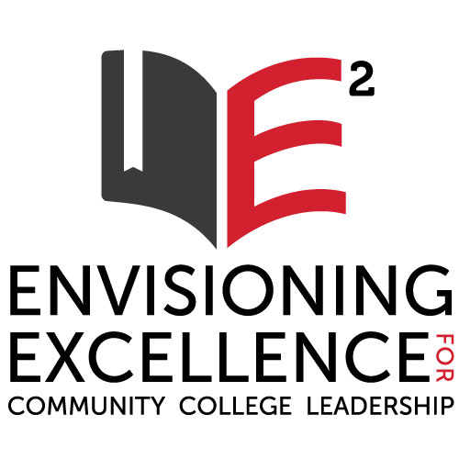
- Research area (In what thematic research areas are you interested?)

For More Information: http://go.ncsu.edu/CCLeadership
Diane Chapman, Director of Raleigh Cohort: diane_chapman@ncsu.edu
James Bartlett, Director of Charlotte Cohort: james_bartlett@ncsu.edu

