NCSU
Counselor Education Program
2019 Employer Survey Report
The Survey
In spring 2019, we identified 192 graduates of the entry level (n=157) and doctoral programs (n=35) between 2015-2019. Surveys were sent electronically to these graduates with a cover letter explaining the survey and requesting their permission and help by asking their employers/supervisors to complete and return the surveys to the program. There were 17 responses, the response rate was 11.4%.
Results
Overall, all items were rated above average to excellent, with item mean scores ranging from 4.38 to 4.92. (See Table 1 and 2) These results are much stronger than the previous survey in 2016, with item mean scores ranging from 3.92 to 4.80. More strong scores were found this year than those in 2016. Out of 17 assessment items, 11 items recorded higher mean scores than those of 2016: research and evaluation, assessment, group counseling, one-on-one relationships with clients, crises intervention, administration, advocacy, professional ethics, using technologies, development treatment/programs, and professional development (items 3, 4, 6-8, 10, 12, 13, 15-17). The mean scores of a few items were similar to the last survey results: understanding nature and needs of individuals and groups (item 1), professional relationships (item 2), assemble, organize and disseminate counseling information (item 5), ranging from 4.54 to 4.77). Only two items had slightly lower means scores than the 2016 scores: liaisons and cooperative working relationships with agencies in the community (item 9) and multicultural sensitivity (item 11). However, these two item mean scores were 4.54 and 4.77, both are still strong scores on a five-point Likert scale. This survey shows that our employers are impressed with our graduates’ professional counseling performance/behavior. The overall findings are excellent and affirm our good teaching and quality programs. It is clear that our graduates are doing very well. No recommendations for curriculum or program changes are suggested. The program faculty may discuss how to increase the response rate of the survey. This may include increasing communication with the alums and employers, involving alums in program activities, etc.
Table 1

Please respond to the following questions about our graduate's performance to the best of your ability. Use the scale from 1 (poor) to 5 (excellent) to rate the graduate of our program on each item.
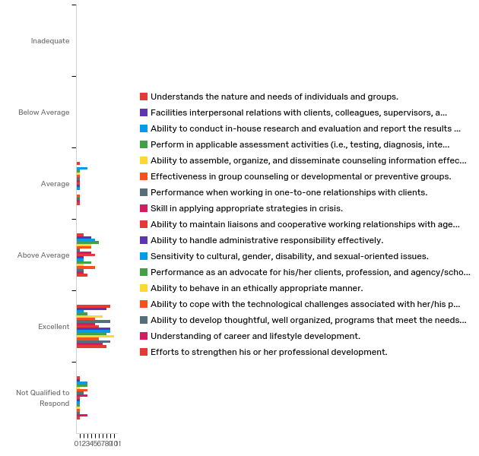

Table 2: Mean Scores Table
# | Items | Mean | Standard Deviation | Variance
1 | Understands the nature and needs of individuals and groups. | 4.77 | 0.70 | 0.49
2 | Facilities interpersonal relations with clients, colleagues, supervisors, and parents. | 4.77 | 0.58 | 0.33
3 | Ability to conduct in-house research and evaluation and report the results clearly to others. | 4.38 | 1.08 | 1.16
4 | Perform in applicable assessment activities (i.e., testing, diagnosis, interpretation, reporting). | 4.62 | 0.92 | 0.85
5 | Ability to assemble, organize, and disseminate counseling information effectively (e.g., career, personal-social, and governmental information). | 4.62 | 0.74 | 0.54
6 | Effectiveness in group counseling or developmental or preventive groups. | 4.77 | 0.89 | 0.79
7 | Performance when working in one-to-one relationships with clients. | 4.92 | 0.73 | 0.53
8 | Skill in applying appropriate strategies in crisis. | 4.77 | 0.89 | 0.79
9 | Ability to maintain liaisons and cooperative working relationships with agencies in the community at large. | 4.54 | 0.75 | 0.56
10 | Ability to handle administrative responsibility effectively. | 4.77 | 0.70 | 0.49
11 | Sensitivity to cultural, gender, disability, and sexual-oriented issues. | 4.77 | 0.70 | 0.49
12 | Performance as an advocate for his/her clients, profession, and agency/school. | 4.77 | 0.58 | 0.33
13 | Ability to behave in an ethically appropriate manner. | 4.92 | 0.47 | 0.22
14 | Ability to cope with the technological challenges associated with her/his position. | 4.54 | 0.75 | 0.56
15 | Ability to develop thoughtful, well organized, programs that meet the needs of clients/students/ or others. | 4.77 | 0.70 | 0.49
16 | Understanding of career and lifestyle development. | 4.92 | 0.83 | 0.69
17 | Efforts to strengthen his or her professional development. | 4.69 | 0.72 | 0.52

